Experiment 5 – uptime, date and mv
Aim: To execute and study the uptime, date, and mv commands in Kali Linux Operating System and observe their outputs.
1. uptime Command
Command:
uptime
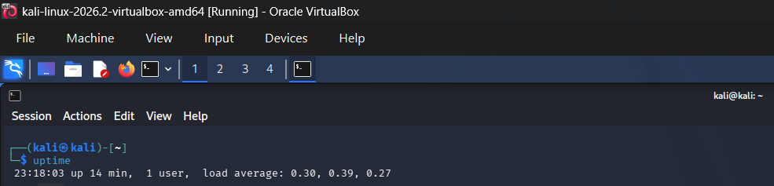
Explanation
The uptime command displays information about how long the system has been running. It also shows the current time, system uptime, number of logged-in users, and system load.
2. date Command
Command
date
Explanation: The date command displays the current date and time of the Kali Linux system.

3. mv Command
Command:
First create a file:
touch oldfile.txt
Then rename/move it:
mv oldfile.txt newfile.txt
Finally, verify it:
ls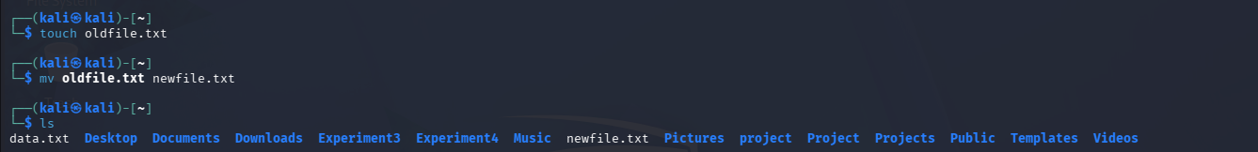

Explanation: The mv command is used to move or rename files and directories.
Here:
mv oldfile.txt newfile.txt
renames oldfile.txt to newfile.txt.
The ls command is used afterward to verify that newfile.txt exists.
Result: Thus, the uptime, date, and mv commands were successfully executed in Kali Linux, and their outputs were displayed and verified.

